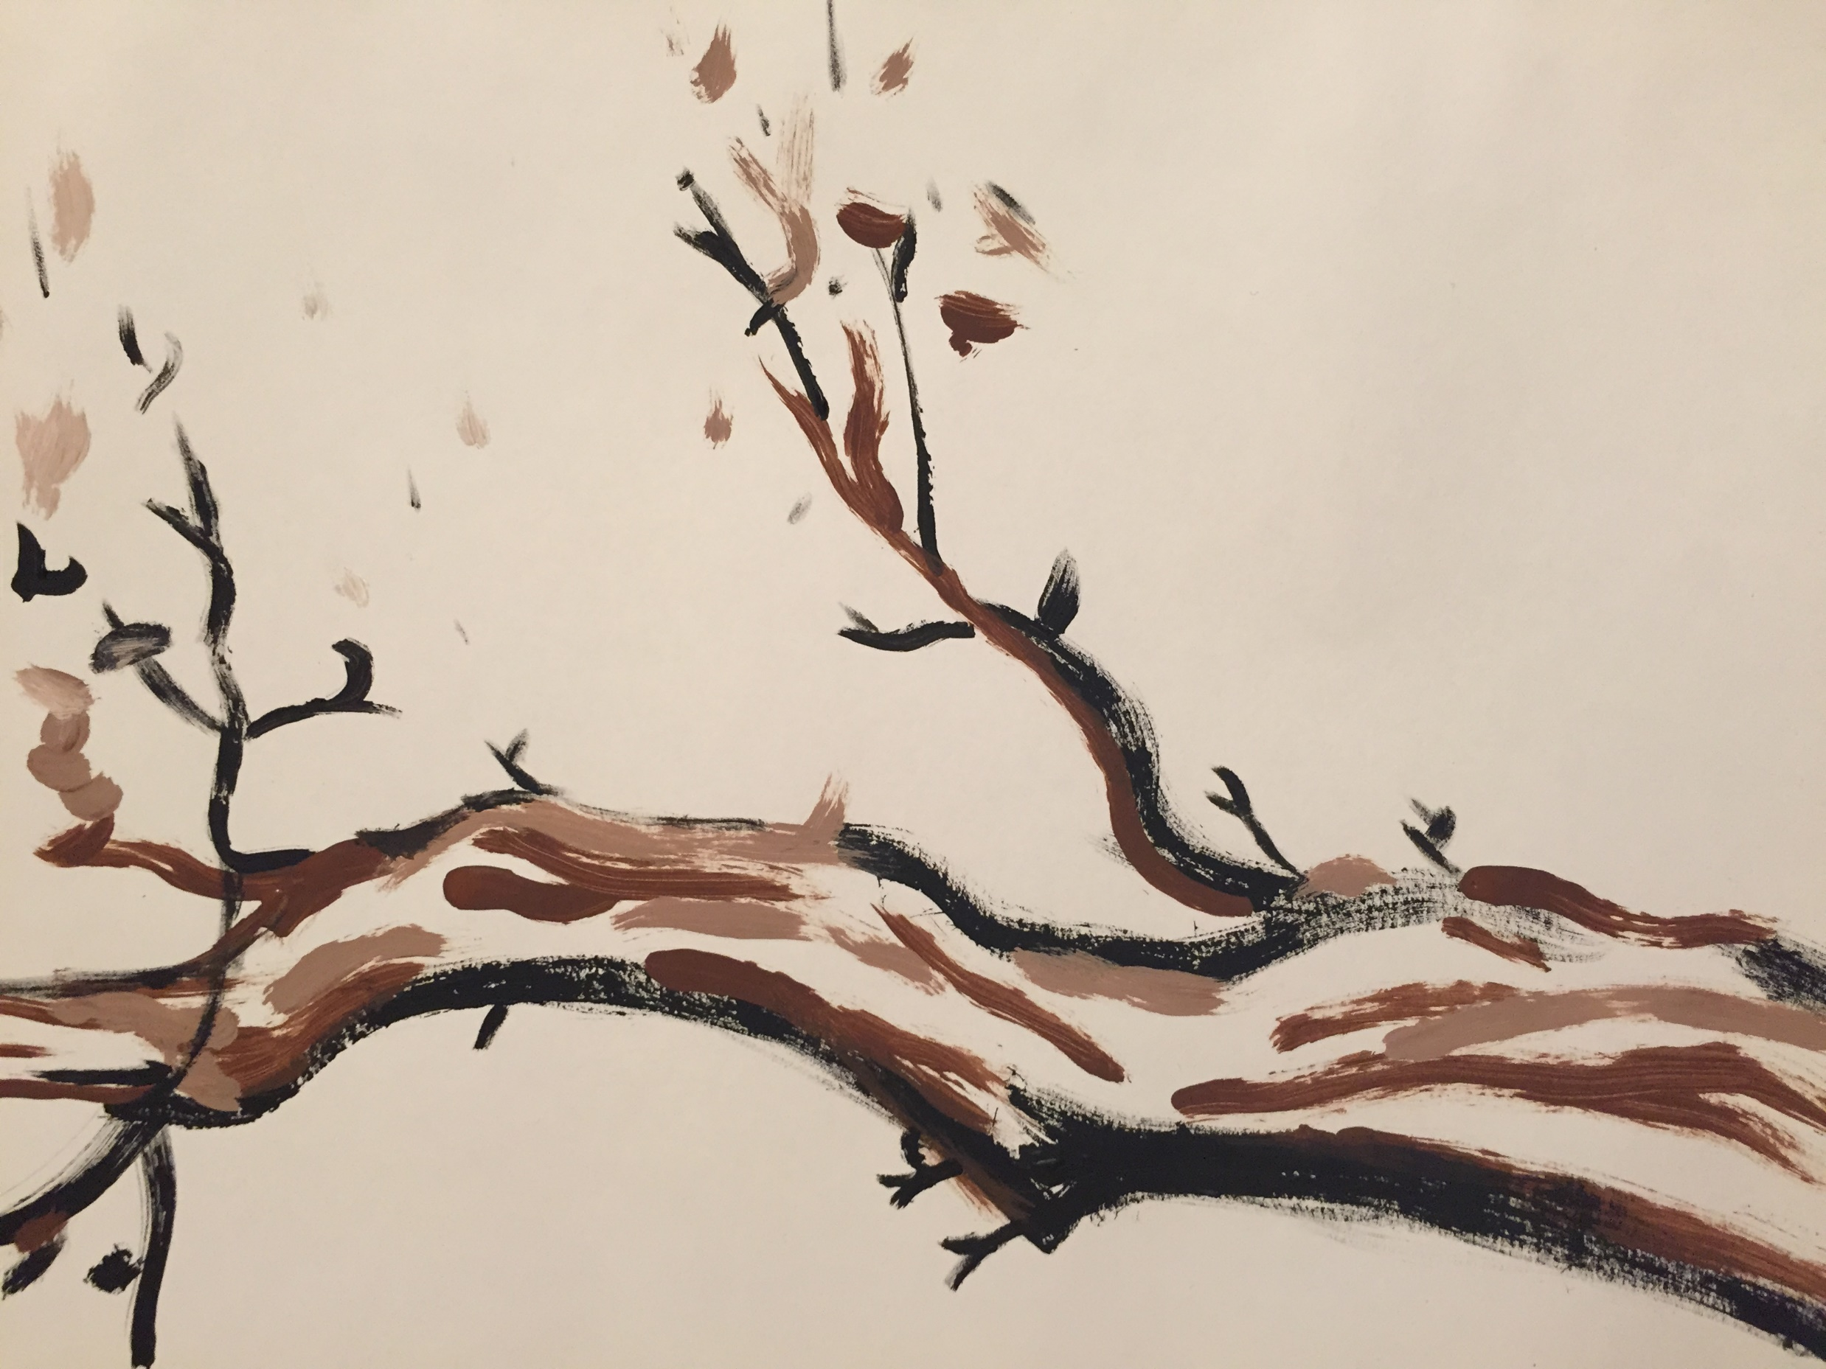

***The U.S. Constitution***

***and the American Economy***

美国宪法与美国经济

This course examines the institutions of the US government and the complex constitutional structure which shapes the American economy.

The US Constitution drew from traditional legal norms found in the Common Law and Natural Law and blended them with modern scientific concepts. The constitutional structure thereby combined principles of natural justice with the realities of economic self-interest. The course will consider how the Constitution used these opposed tendencies to create a large commercial republic.

The course will aim at understanding how, in practice, American institutions and processes interweave notions of natural justice and positive law to shape the US economy and its constitutional order.

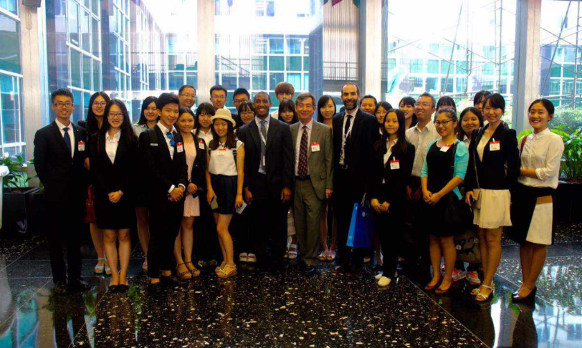

Visit to the U.S. State Department, 2015

To Apply:

Submit in English:

1) a letter of good standing from your university or employer, and

2) the application form available online <http://www.law.georgetown.edu/academics/centers-institutes/constitution/us-constitution-american-economy/index.cfm>

Applications are accepted until all slots are full but please allow time for Georgetown to write the letter needed for the visa. Please apply by mid-April.

Email to [lrk37@georgetown.edu](mailto:lrk37@georgetown.edu)

If you do not receive confirmation within one week, please contact us.

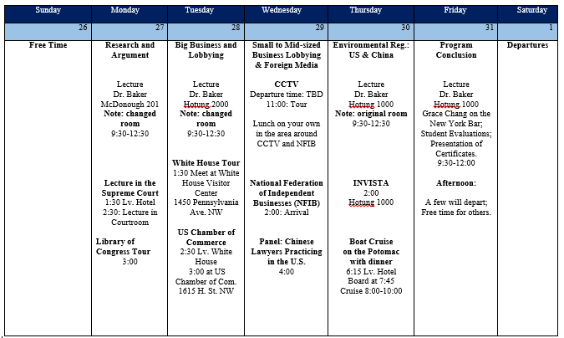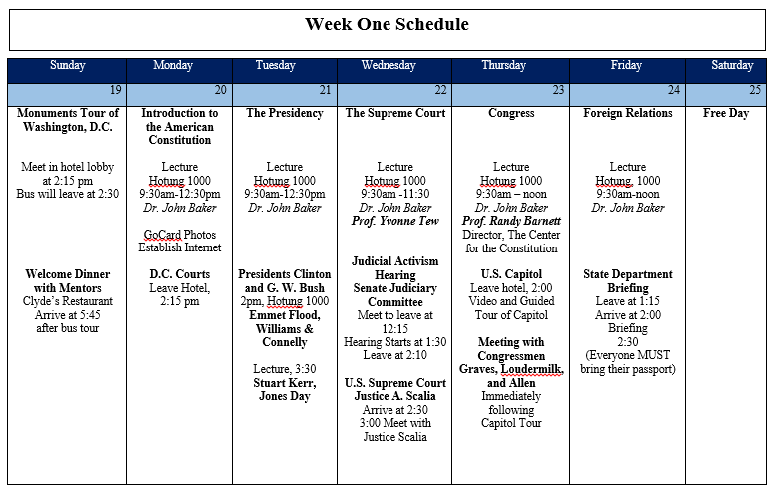

Georgetown University Law Center

http://www.law.georgetown.edu/academics/centers-institutes/constitution/us-constitution-american-economy/index.cfm

Below are weekly event schedules from 2015 course.

***The program is a two week course held in Washington, D.C., which will run from July 17 – July 29.***

COSTS

The cost of the program usually runs around US$4000. This includes the program fee (and included tours and activities) and hotel lodging for the duration of the course. Meals are not included. See website for exact cost totals.

If the full payment is received by May 1, 2016, students will receive a $150 discount. See website for payment details.